Q1 | Download a sample CSV file of IPL player stats (include columns like player name, runs, matches, and some missing values). Load it into a pandas DataFrame and use isnull() and notnull() to print how many missing values are present in each column.
Code | import pandas as pd  df = pd.read_csv("ipl_player_stats.csv")  print("IPL Player Stats:")  print(df)  print("\nMissing values:")  print(df.isnull().sum())  print("\nNon-missing values:")  print(df.notnull().sum())
Output | 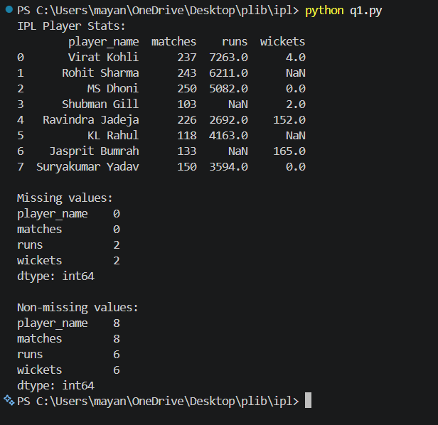

Q2 | Using the loaded IPL player stats DataFrame, apply dropna(axis=0, how='any') to remove all rows with any missing data and display the shape of the DataFrame before and after dropping.
Code | import pandas as pd  df = pd.read_csv("ipl_player_stats.csv")  print("Shape BEFORE dropping rows with missing values:")  print(df.shape)  df_cleaned = df.dropna(axis=0, how="any")  print("\nShape AFTER dropping rows with missing values:")  print(df_cleaned.shape)  print("\nDataFrame after dropna:")  print(df_cleaned)
Output | 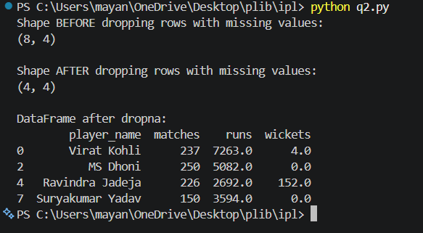

Q3 | For the 'runs' column in your IPL player stats DataFrame, use fillna() to replace missing values with the mean of the column. Print the updated column to verify the changes.
Code | import pandas as pd  df = pd.read_csv("ipl_player_stats.csv")  runs_mean = df["runs"].mean()  print("\nMean of runs:", runs_mean)  df["runs"] = df["runs"].fillna(runs_mean)  print("\nUpdated 'runs' column after fillna(mean):")  print(df["runs"])
Output | 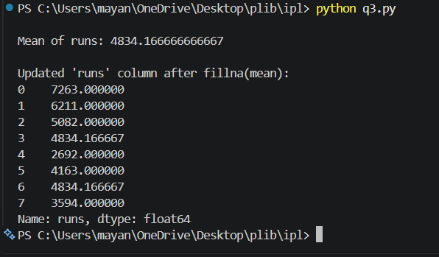

Q4 | Simulate a Zomato-style restaurant ratings dataset with some missing ratings. Use forward fill (method='ffill') to fill missing values in the ratings column, then use backward fill (method='bfill') for any remaining missing values. Show the before and after results.
Code | import pandas as pd  df = pd.read_csv("zomato_ratings.csv")  print("BEFORE FILLING MISSING VALUES:")  print(df)  df["rating"] = df["rating"].ffill()  df["rating"] = df["rating"].bfill()  print("\nAFTER FILLING MISSING VALUES:")  print(df)
Output | 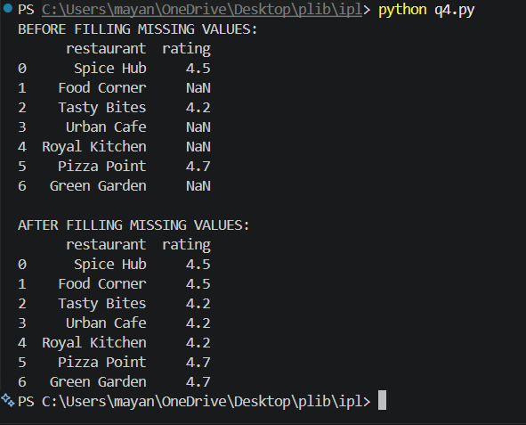

Q5 | Pick any one column with missing values from your dataset and explain which missingness mechanism (MCAR, MAR, or MNAR) is most likely and why, using 2-3 sentences.<br><br><em><strong>Hint:</strong> Think about whether the missing data is random or related to other factors in the dataset.</em>
Answer | The rating column is most likely MCAR (Missing Completely At Random) because the missing ratings do not appear to be related to the restaurant name or any other factor in the dataset. The missing values seem to occur randomly, so there is no clear pattern explaining why some ratings are missing.

